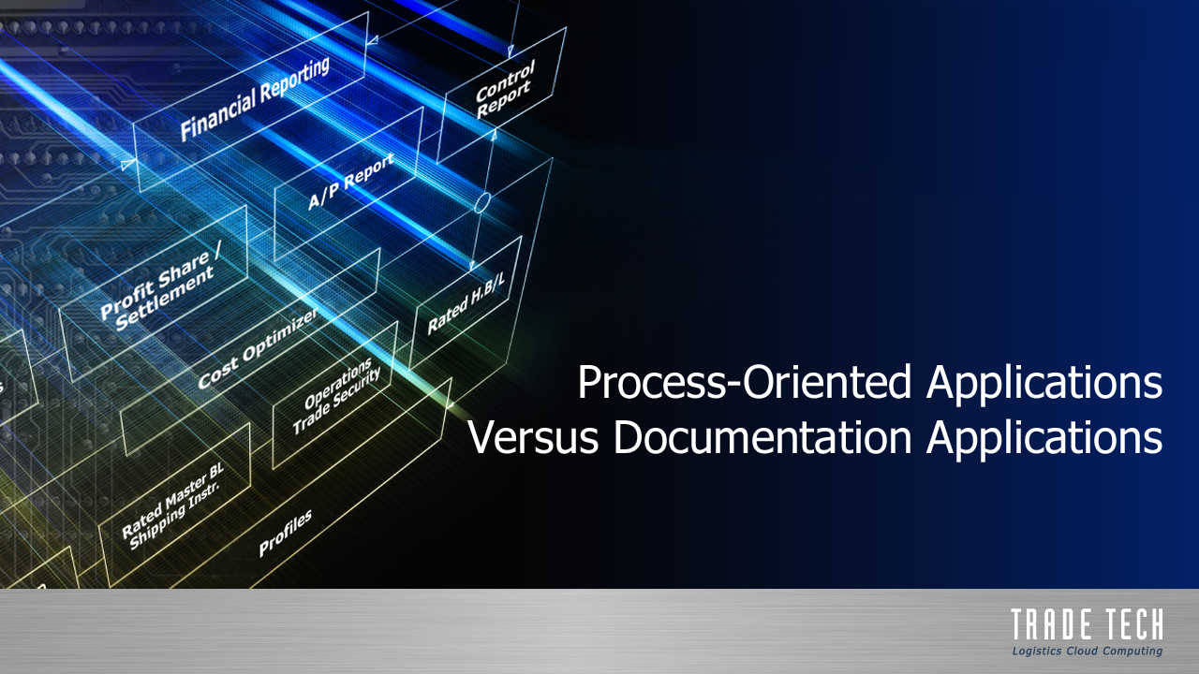

Cargo Security Monitoring
User Manual
NVO/FF Ocean mode of Transportation

updated September 1st, 2020

Developed by Trade Tech, Inc. (Headquarters)
710 5th Ave NW, Suite 200
Issaquah, WA 98027 USA
Tel: +1.425.837.9000

Website: https://www.tradetech.net/
User login page: https://login.tradetech.net/ or https://login2.tradetech.net/
Global Customer Support Ticketing System: https://tradetechhelp.zendesk.com/,

Table of Contents

- Logging in p. 3

- Searching for Shipments p. 3
a) Cargo security In Progress (Monitor filing status) p. 3
b) Quick Search (Shipment Information) p. 5
c) Shipment in progress (Shipment Information) p. 5

- Monitor filing status p. 6

- Shipment Information p. 9
a) Essentials p. 10
b) Compliance p. 11
c) Route p. 11
d) Administrative Workflow p. 11
e) Shipment Specifics p. 12
f) Consignment Parties p. 12
g) Security/Compliance p. 13
h) Container Information p. 13
i) Vessel Information p. 14
j) Shipment Events p. 14

- Compliance p. 15
a) AMS/ISF (USA) p. 15
b) ACI/eManifest (Canada) p. 16
c) AFR (Japan) p. 18
d) RCG (South Africa) p. 20

- Certificate issuance p. 21

- Login

Log in Trade Tech Syrinx portal using your secure login credentials.
Note that your ID and password are case sensitive.

Access Trade Tech website using URL https://login.tradetech.net/ or https://login2.tradetech.net
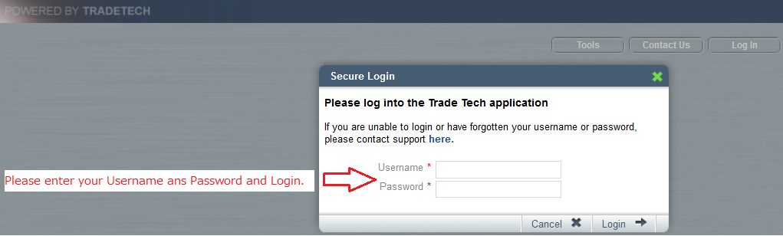

- Searching for Shipment

a) Cargo Security In Progress (Monitor filing status)

Use “Cargo Security In Progress” from SELECT A REPORT drop down menu to monitor security filing status. This is useful when you need to find a certain security type such as AMS, ISF, eManifest, AFR, RCG, etc…

Under Trade Manager menu, click “REPORTS”, move to “Cargo Security” then select “Cargo Security in Progress”.

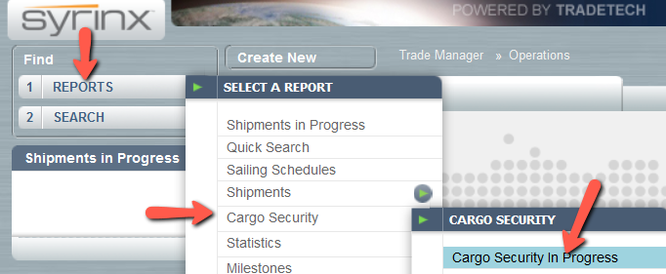

Select Security Type from the dropdown menu to search for your shipments which are in progress for that specific security type, then press Go.
You can enter specific criteria to filter your query (HBL#, MBL#, container #, …etc).

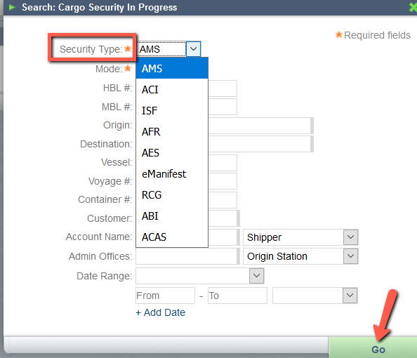

You can also narrow your search criteria by HBL#, MBL#, container #, vessel…etc.
The report displays all the In-progress filing(s) for your office station.

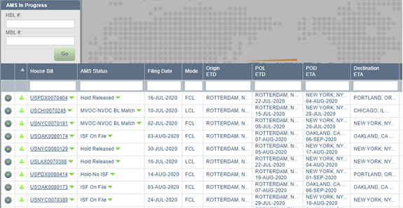

The results can be downloaded to excel by pressing “Export to excel” button bottom right side of the report.

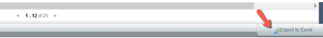

b) Quick Search (Shipment information)

If you know House Bill #, or Master Bill#, you can use the “Quick Search” report option.

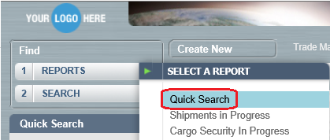

Fill in the number, press “Go”
Then click House Bill blue hyperlink to open the shipment screen.

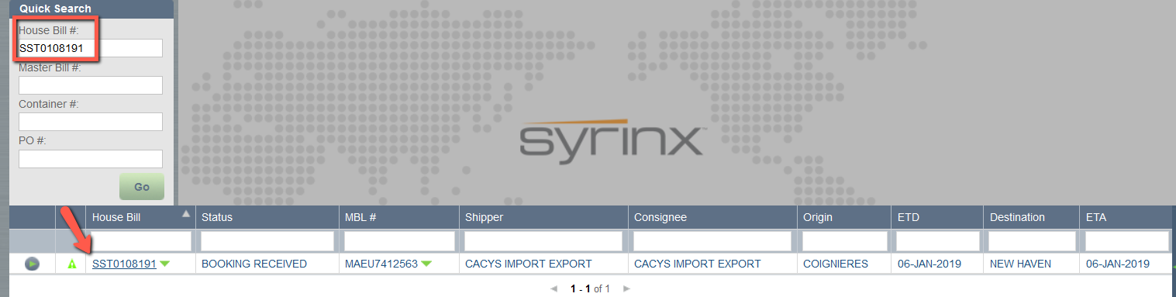

c) Shipment In Progress (Shipment information)

If you need to scop down Shipment Type, you can use “Shipments in Progress”.
Choose among FCL/LCL/BKK or AIR and click GO to search.
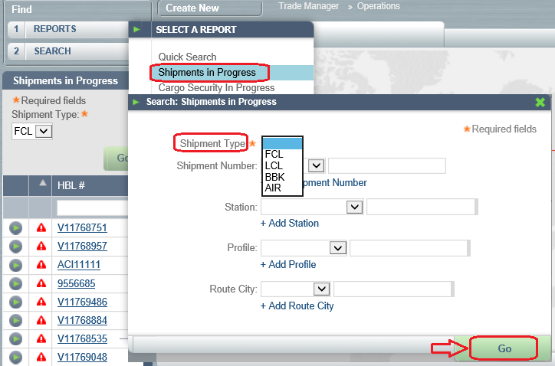

You may also narrow your search criteria by Shipment Number (HBL#, MBL#, Container #, …etc), Station, Profile and/or City.

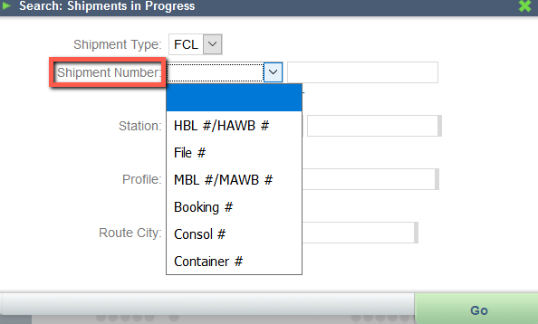

- Monitor Cargo Security Filing Status

In order to monitor your In progress filings status, please use the “Cargo Security In progress” report. Trade Manager tab -> Reports -> Cargo Security -> Cargo Security In Progress

Select Security Type and Mode (Ocean/Air) then press Go.

You can also search for a dedicated shipment using criteria listed in the query.
In the Security In progress report, look at “Status” column, this confirms the current status of your filing. Pay attention to negative status such as rejections, hold, container mismatch, etc…

The filing date indicates the date initial manifest was submitted to customs.
Make sure your filing get positive match 24 hrs before vessel sailing.
ETD is displayed in the POL column.

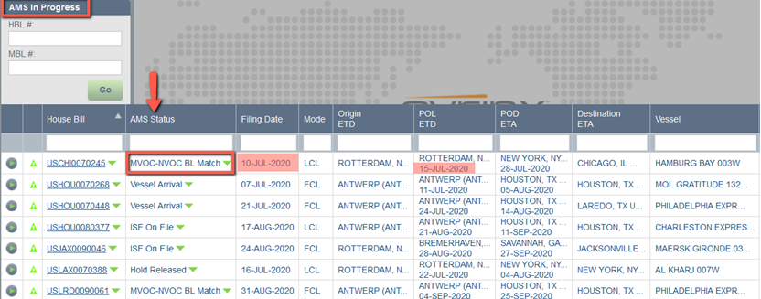

In progress also reports brief description of the shipment information such as origin/destination, POL/POD, ETD/ETA, Vessel information, Shipper, Consignee, and origin office (Filing desk/Entered by station).

You can sort the In-Progress report by clicking on this column titles, a greyed-out triangle indicates which column the report is sorted by.

You can also use the blank field under column title to filter the report. The filter runs a “contains” search. Click on the cross, right side of the cell to remove the filter.

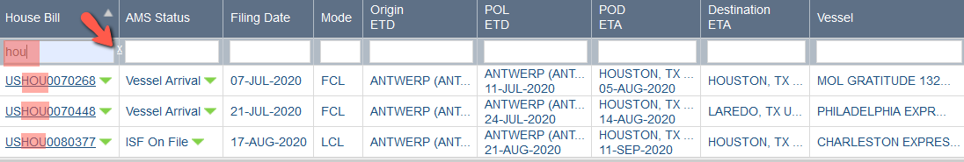

Click on the left triangle to view the Transmission Log window, this provides the archive of back and forth messages to/from customs from the initial to the most current message.

Description displays customs disposition code, followed by a brief description of what the code means. It also lists the recipients to whom the message has been distributed to (“Sent E-Mail To” = billing account contacts).

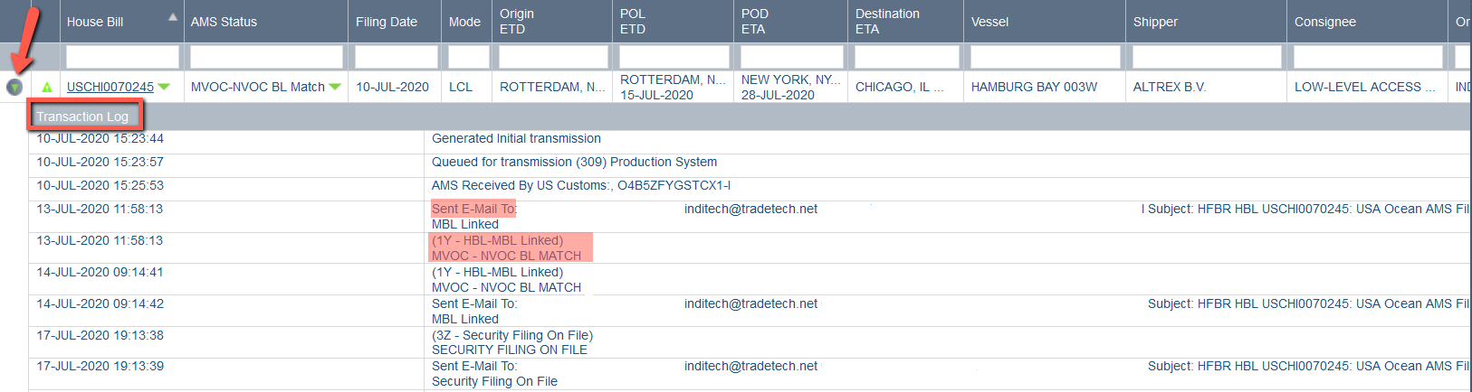

The AMS and ISF In Progress allows to quickly check the corresponding ISF or AMS status by moving your mouse on the green arrow right side of current status

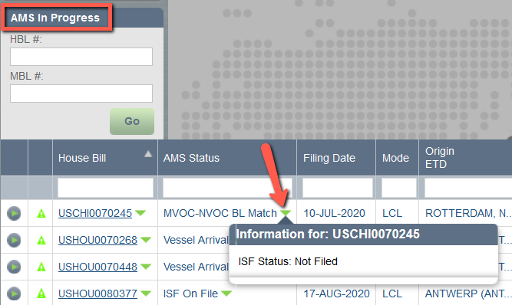

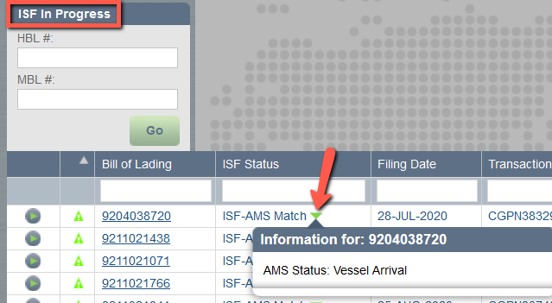

Again, move your mouse on green arrow near House Bill blue hyperlink to quickly check Master Bill number.

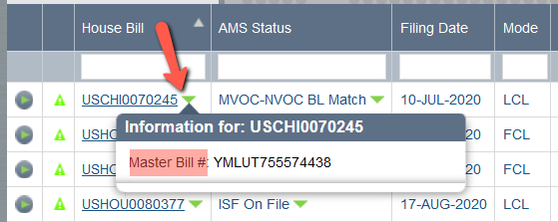

- Shipment Information

Click on The House Bill blue hyperlink to open shipment details.

You can move from one shipment screen to others just clicking on HBL blue hyperlink left side case by case, the current screen will refresh straight forward with the new HBL details without closing current page.

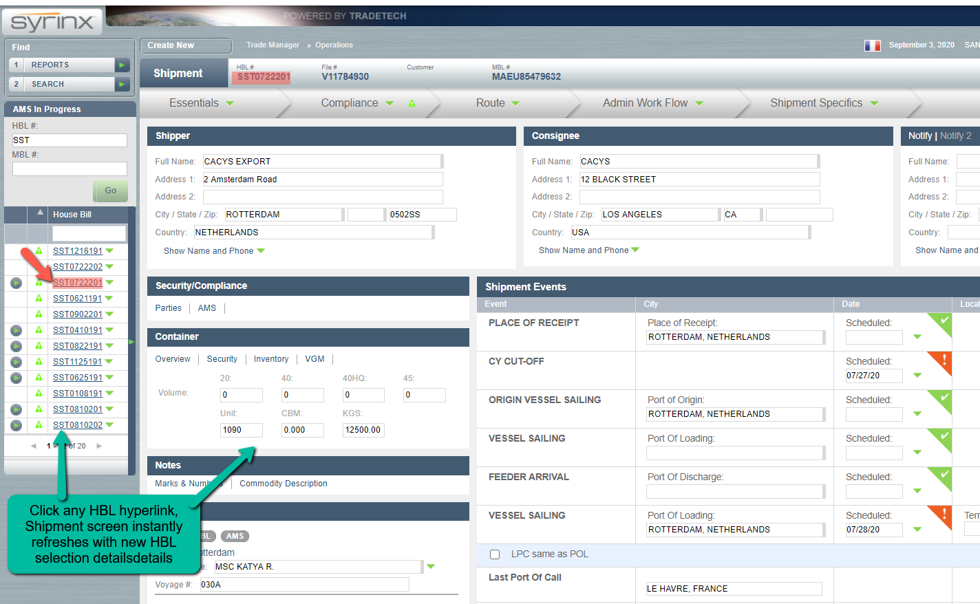

Top of shipment screen displays Documents numbers such as HBL# and MBL#
(File# = TT shipment chrono).

You can move from wizard to others (Essentials, Compliance, Route, Administrative workflow, and Shipment Specifics).
Click on the wizard title to open it. Then press continue will move to the next wizard (from left to right), or you can cross the box and click on other wizard title.

a) Essentials

Essentials wizard displays shipment preferences such as shipment type, carrier, …

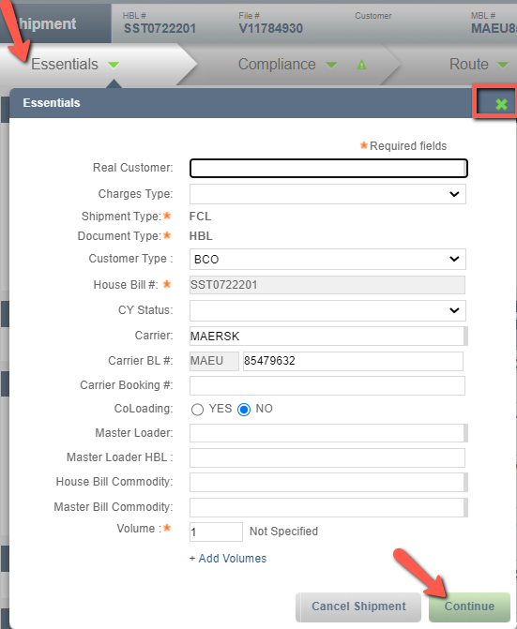

b) Compliance

The Compliance wizard shows the type of entry selected for the manifest(s) submitted for that shipment, and current status (same as the one reported in the In Progress Status column).
Move your mouse on the green arrow to view back and forth messages with customs (archive similar to the Transaction Log window in the In Progress).

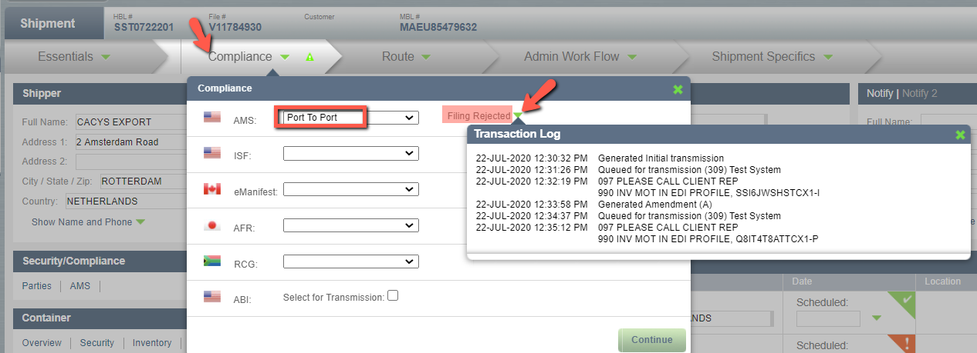

c) Route

This wizard confirms shipment routing, as well as the manifest(s) which applies on the leg.

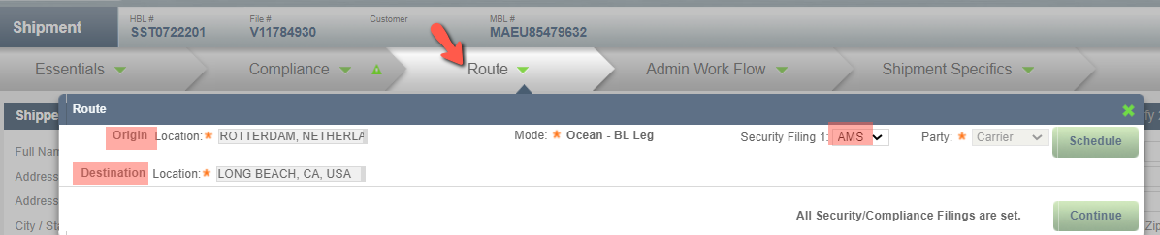

Multiple security filing types may apply for the same shipment leg(i.e AMS and ISF)

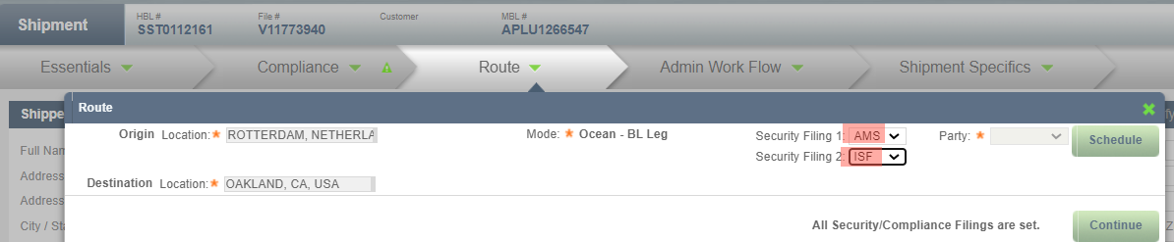

Also, if multiple legs manifests are involved in the shipment, the Route will display the connection and the respective security filing type per leg destination.

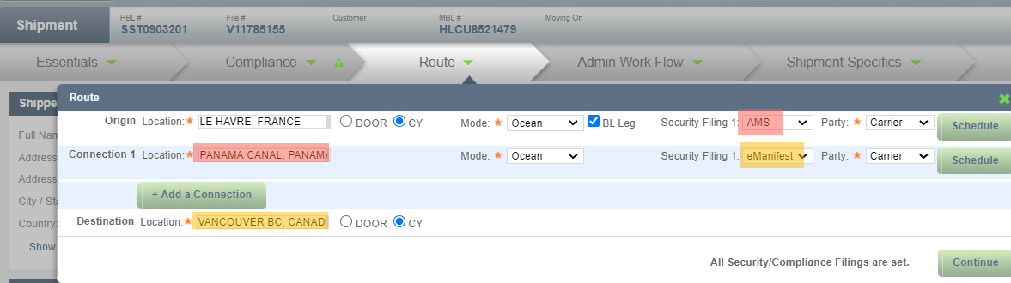

d) Administrative Worflow

Administrative workflow displays the stations allowed to view the shipment information.
Origin station reflects the filing desk (entered by station).

e) Shipment Specifics

This wizard may be used to enter certain data for specific types of filing
(ie. “Unique Consignment Reference” for RCG export manifest from South Africa)

f) Consignment parties

The shipper, consignee (and Notify party when required data) are displayed on top of the shipment screen. Move your mouse on the green arrow to view Name and Phone when required (ie. AFR)

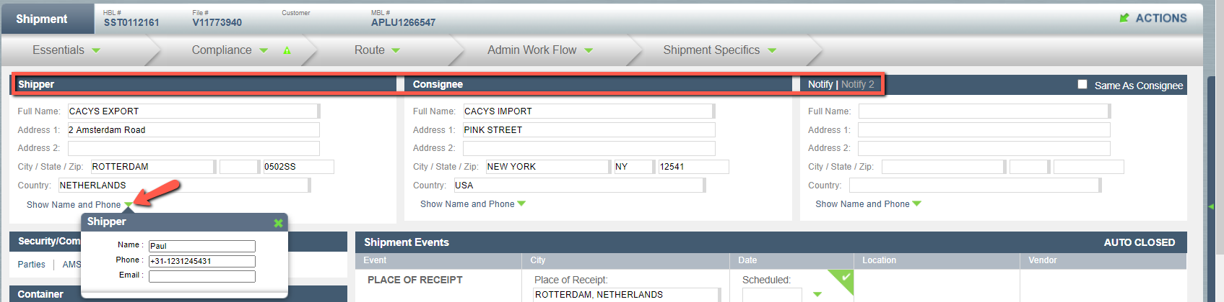

g) Security/Compliance

This section allows to manifest parties and identification details for specific filing type. (i.e: ISF Importer of record for ISF filing)

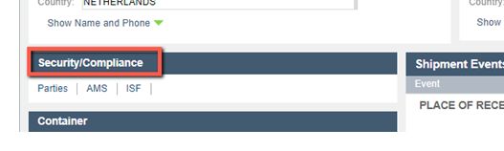
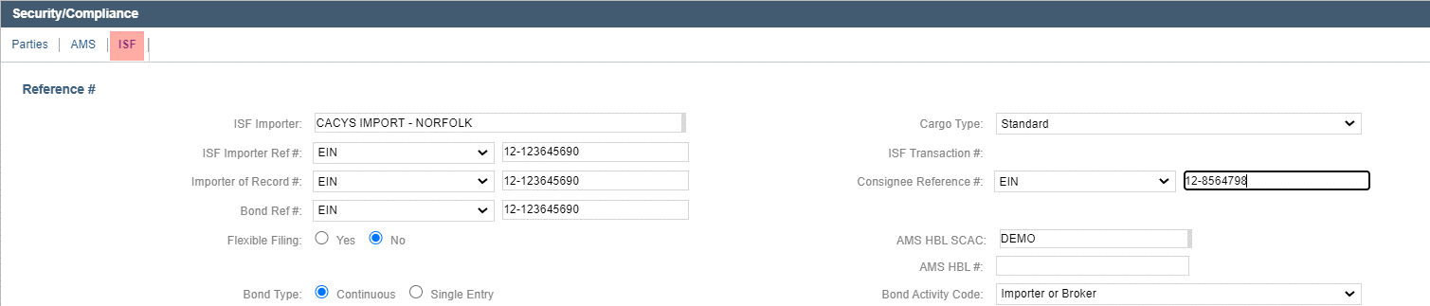

h) Container

This section allows an overview of the container and cargo details

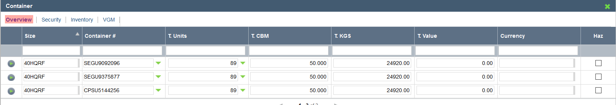

Click on “Security” to view datas required upon the manifest type, such as commodity description, marks and numbers, HS code, etc…

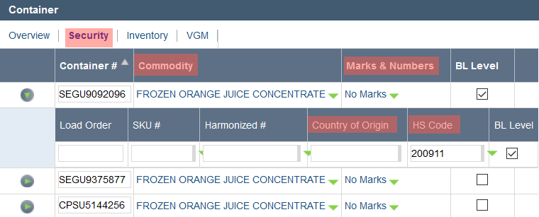

i) Vessel Information

Vessel details are displayed in the “Routing” section bottom left of the shipment screen.
Move your mouse on the green arrow right side of the vessel name to view Vessel IMO and Flag.

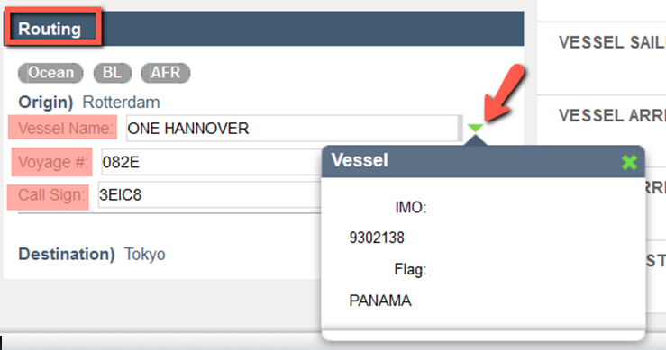

j) Shipment events

This section shows detail of the routing, and potential location code which may be required for certain type of filing (ie. Terminal code for RCG or eManifest).

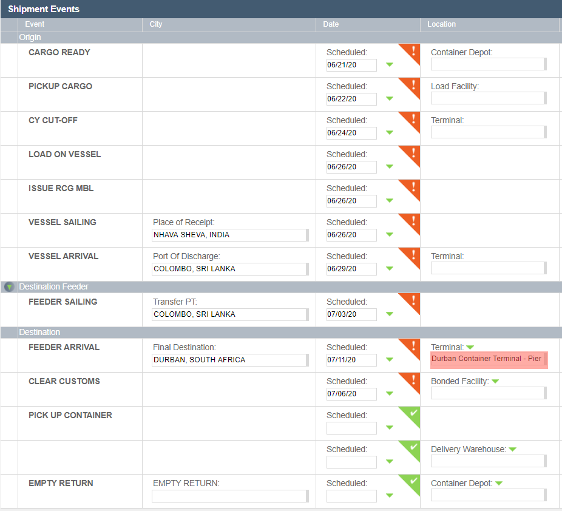

- Compliance

a) AMS/ISF

i. Timeline for submission

As a reminder, AMS/ISF must be filed 24hrs before prior loading on the vessel:
- at port of loading for direct shipments
- at port of transshipment for non-direct shipments
The filings must be manifested on the Vessel that discharge or calls US port.

ii. Type of entries

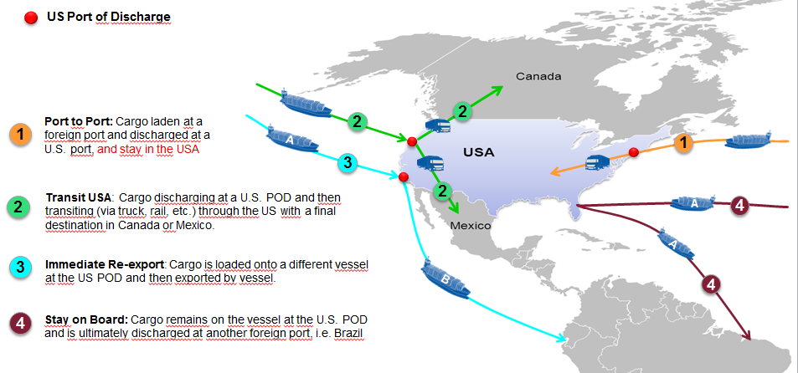

iii. Data requirements

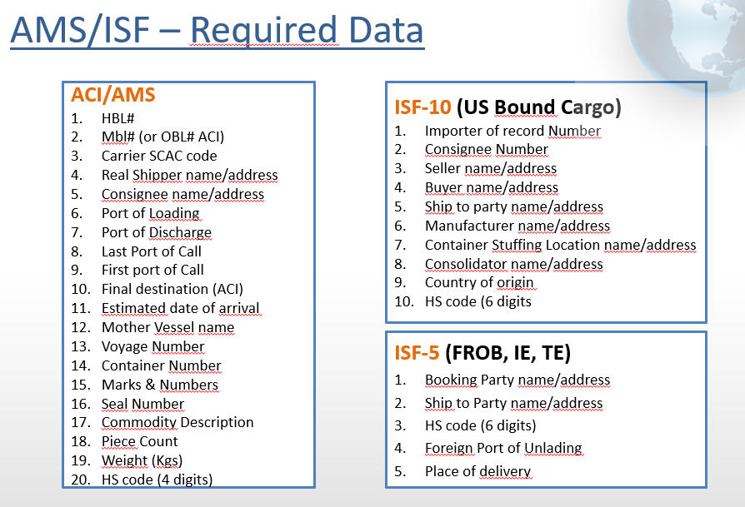
iv. Disposition codes

Make sure to monitor below positive messages from customs:

1Y - HBL and MBL Linked - means both carrier and NVOCC AMS match
If no 1Y is received within 24 hours, 2 potential reasons:
- Carrier did not file AMS for its Master Bill yet
- There is a discrepancy with MBL# manifested by carrier
Contact carrier and check potential discrepancy.

3Z - Security Filing on File - means both the AMS and ISF filing match
Note : ISF must be filed against the SCAC + Bill Number under which the cargo moves
If no 3Z is received within 24 hours, 2 potential reasons:
- ISF filer did not file ISF yet
- The ISF was filed against different SCAC and HBl# than one used for AMS filing
Contact ISF filer and check potential discrepancy

v. Potential errors/rejections

Please pay special care on the below errors, they are quite regular:

299 - CARRIER BL NOT ON FILE AS MVOC TYPE.
This error means carrier filed their Bill of lading as REGULAR/DIRECT type instead of MASTER type, which prevents the 1Y match
Contact the carrier and ask them to change their filing to MASTER (NVO HBl underneath).
In order to prevent this error, make sure to advise the carrier you are AMS self- filer at time of booking.

2Z – Container Mismatch
This error means both the NVO and Carrier Bill match BUT there is a mismatch between the container number manifested both sides.
Contact carrier and check about discrepancy.

b) ACI/eManifest

i. Rule
ACI - Advanced Commercial Information became mandatory in 2006.
eManifest - Electronic House Bill Data submission – will became live November 1st, 2020 A 6 months informed compliance, zero rated penalty period, will start January 4th, 2021.

ii. Timeline for submission

A FF must respect the pre-established ACI mode specific timelines when submitting their House Bill data, meaning 24 hours prior to loading for ocean, and 4 hours prior to arrival for air.

iii. Data requirements

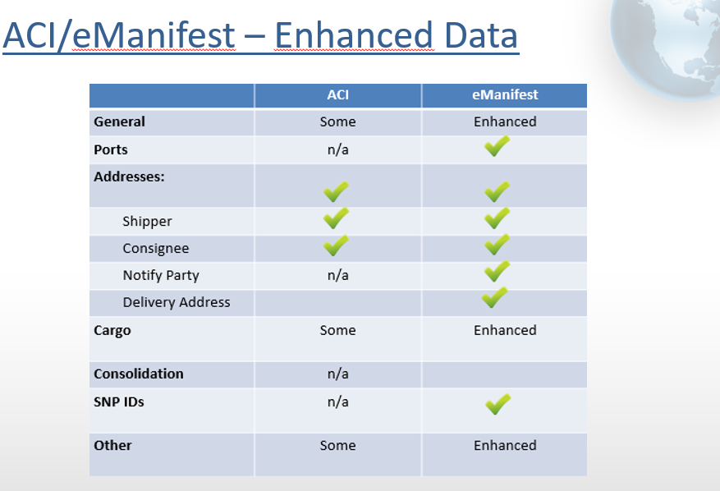

iv. Disposition codes

Make sure to monitor below positive messages from customs (ACI or eManifest related)

06 – Confirmation - indicates ACI/eManifest is accepted by Canadian customs (CBSA)

SL – Supplementary Report Linked - confirms NVO House Bill (ACI) is linked to Carrier Bill

0001 – Matched - means NVO HBL (eManifest) is linked to all its related trade documents in the chain.

Same as AMS/ISF, if no positive message is received within 24 hours, 2 potential reasons:
- Carrier did not file the manifest yet
- There is a discrepancy on the MBL# manifested carrier side versus NVO side

In the case of an eManifest, the “Matched” confirmation is received when all documents in the chain are linked all together. Upon the number of documents (carrier + co-loader + nvoccs), it may take more than 24hrs to receive the Match.

v. Potential errors/rejections

44 – Rejection (ACI only)
Cause of rejection can be multiple.
ie: “463 - Cargo Control Number (CCN) (Empty or Export) /Supplementary INVALID” which is equivalent to “299” for AMS, carrier did not manifest its MBL as MASTER type preventing the link. Ask carrier to update their ACI filing as MASTER type.
Any other rejection, do not hesitate to contact our support team if you need to clarify the rejection.

Q75 Container Prefix/Container Serial Number FIELD IS INVALID (ACI only)
This error is equivalent to a “2Z” for AMS. There is container mismatch.
Contact carrier to resolve discrepancy.

eManifest potential errors have not been defined yet.
We will distribute dispositions codes once available.

c) AFR

i. Rule and timeline for submission

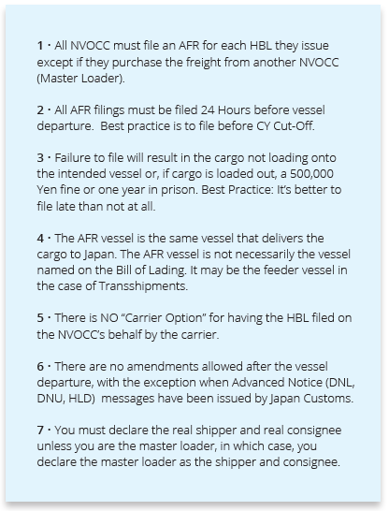

ii. Data Requirements
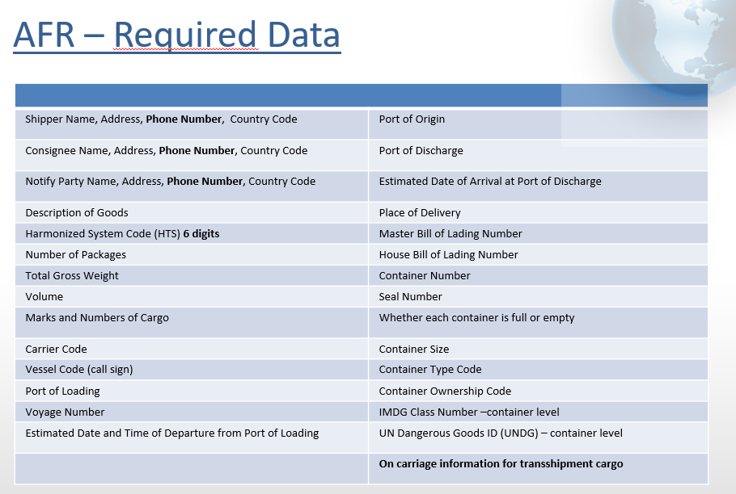

iii. Disposition codes

Japan customs (NACCS) does not have specific disposition codes for confirmation of the link. Instead, our system is designed to send auto-amendment to NACCS until they confirm your HBL has linked to carrier BL.

On File/Linked
Means the AFR filing is on file with Japan Customs, and HBL and MBL are linked.

On File/Not Linked (NL2)
Means the AFR filing is on file with Japan Customs BUT carrier has not filed AFR for its MBL, which prevents HBL and MBL to be linked
There are 2 potential reasons:
1. The carrier did not file the AFR yet
2. The MBL# entered in shipment file is not correct
Check exact MBL# to use for AFR manifest with carrier.

On File/Not Linked (R) (NL1)
This means the AFR filing is on file with Japan Customs BUT the carrier has filed AFR as REGULAR Bl type instead of MASTER type preventing HBL/MBL link
Ask carrier to change their AFR filing to MASTER Type for match.

iv. Potential rejections

DNL – Do Not Load
DNU – Do Not Unload
HLD – Hold

Exact reason is described in the customs message. Make sure to diligent resolution.

d) RCG

i. Rule and Timeline for submission

RCG stands for Reporting Of Conveyance and Goods.
It became mandatory for all shipments Ocean and Air from/to Republic of South Africa on November 1st 2018.

FF must respect the pre-established RCG mode specific timelines when submitting their House Bill Data to SARS (South Africa customs)

- 24hrs prior to loading for cargo moving under FCL Master House Bill TO RSA
- 24 hrs prior to arrival for cargo moving under LCL Co-load House Bill TO RSA
- 3 working days prior to loading for cargo moving under House Bill FROM RSA

ii. Data Requirements

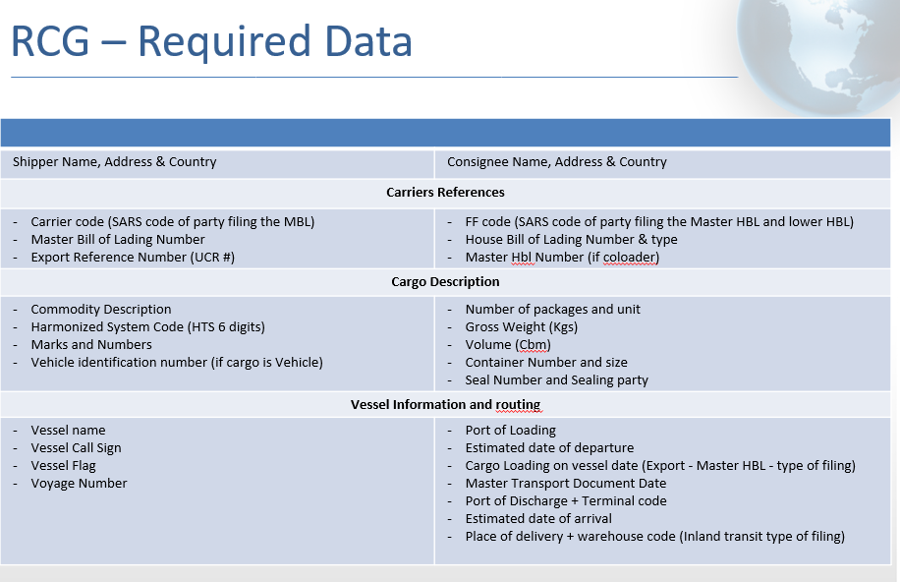

iii. Disposition codes/Rejections

There is no “Match/Link” concept in place at SARS, they confirm acceptance as follow:

8 – Proceed to Border is the positive confirmation you must attend

The rejections/errors are quite limited.
Major case an error is received for incorrect vessel information
(6 – Notification, followed by error 2000 - VALUE NOT IN CODELIST HDR TRANSPORT ID).
Confirm vessel calling South Africa with carrier.

Full list of disposition codes and errors per security filing type are available upon request

- Filing Certificate

In some case, you may need to confirm the filing to carrier (or any other party).

Open the “Action menu” section by clicking on the green arrow straight right of the shipment screen
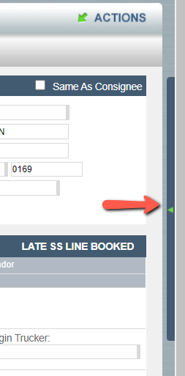

or clicking on “ACTIONS” top right side of the web page. Then “Print” the certificate.

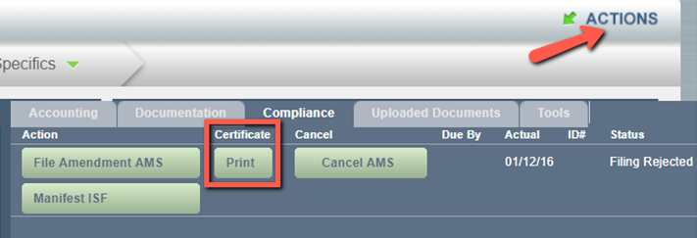

No form set up is required, jus click “Next”

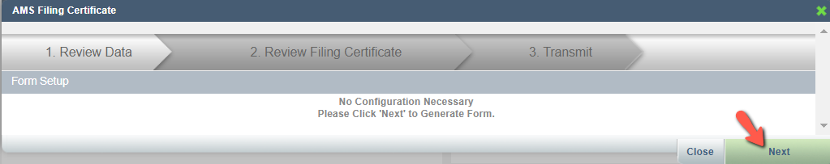

Review the form and press “Next”

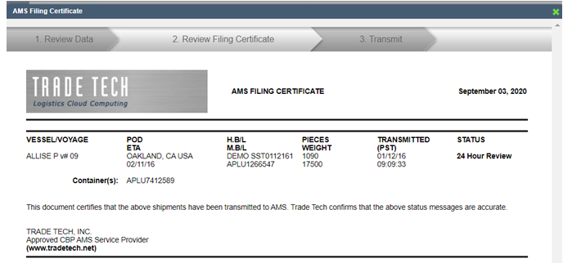

Select Print or Email.
For email, add recipients, enter email, then press “Send”

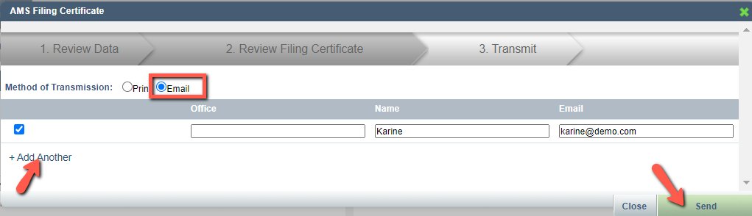

Do not hesitate to open a ticket should you need clarification on customs status:
Logs in https://tradetechhelp.zendesk.com/,
or email support@tradetechhelp.zendesk.com

